**Safeg**

**Safeguarding Team**

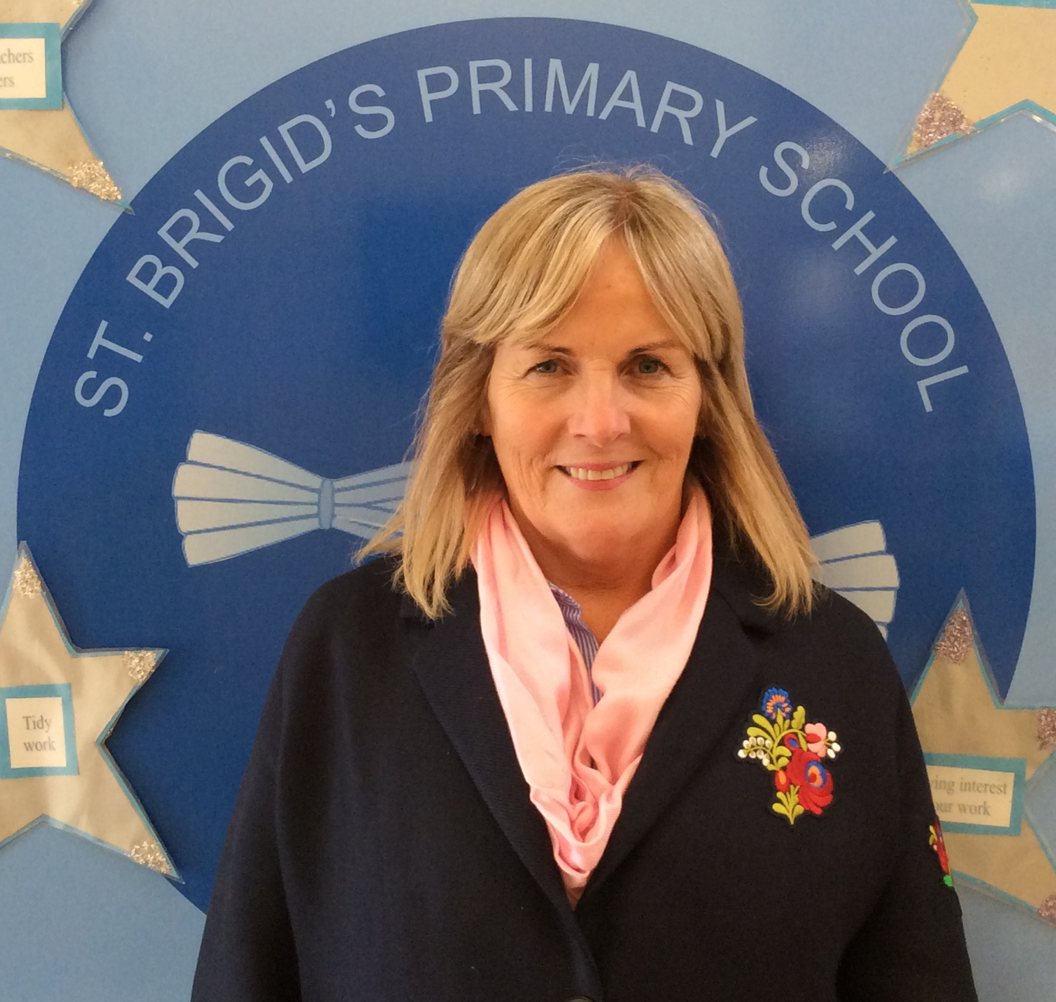



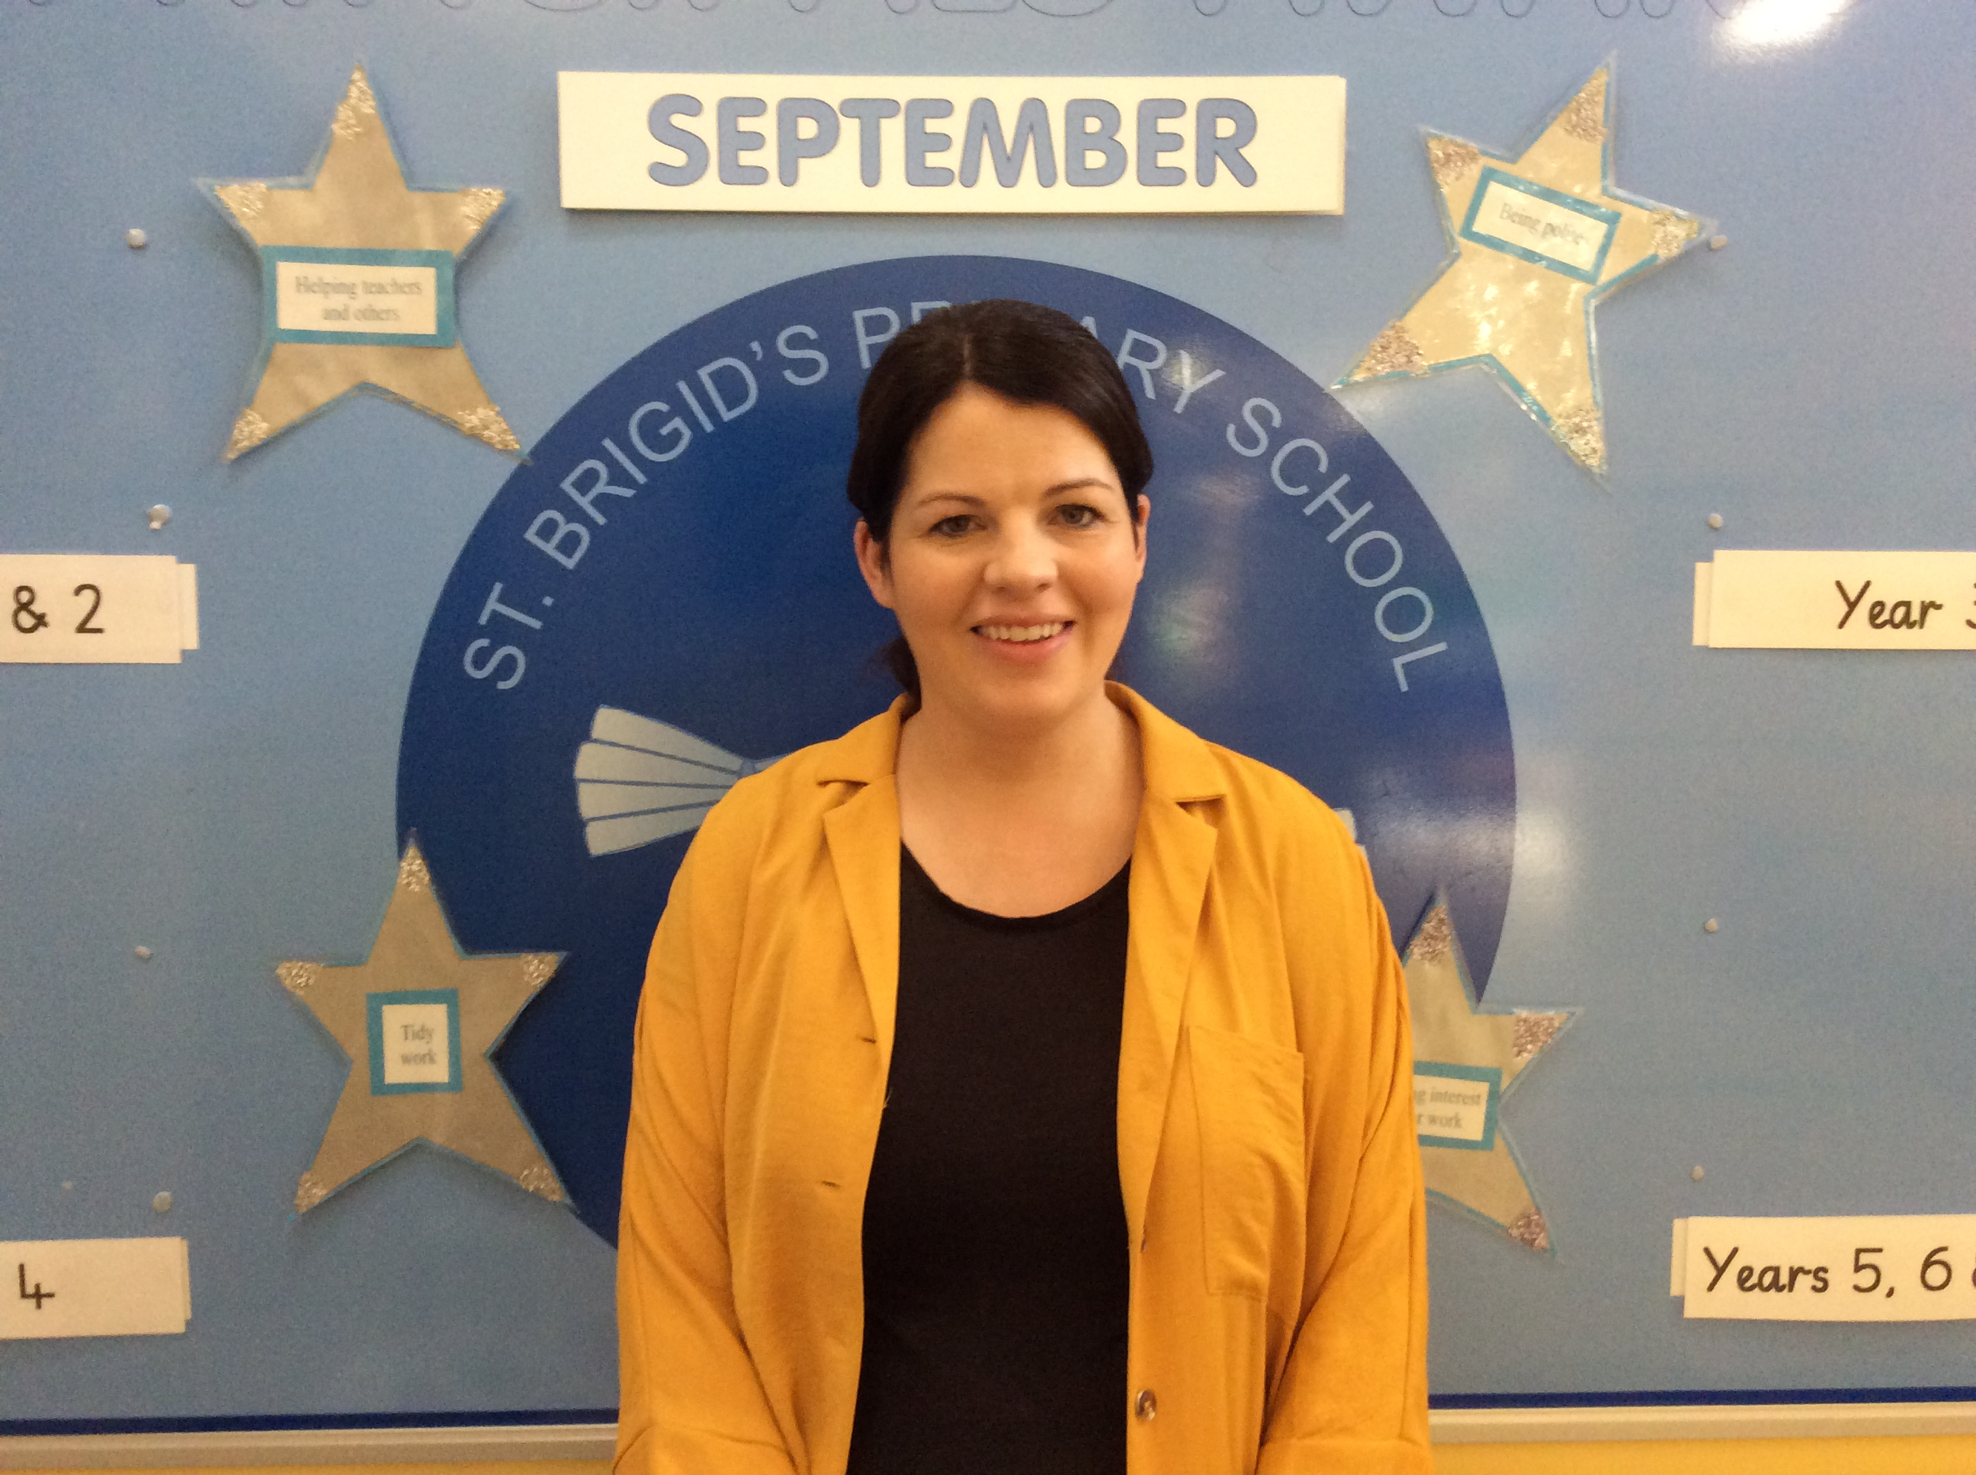

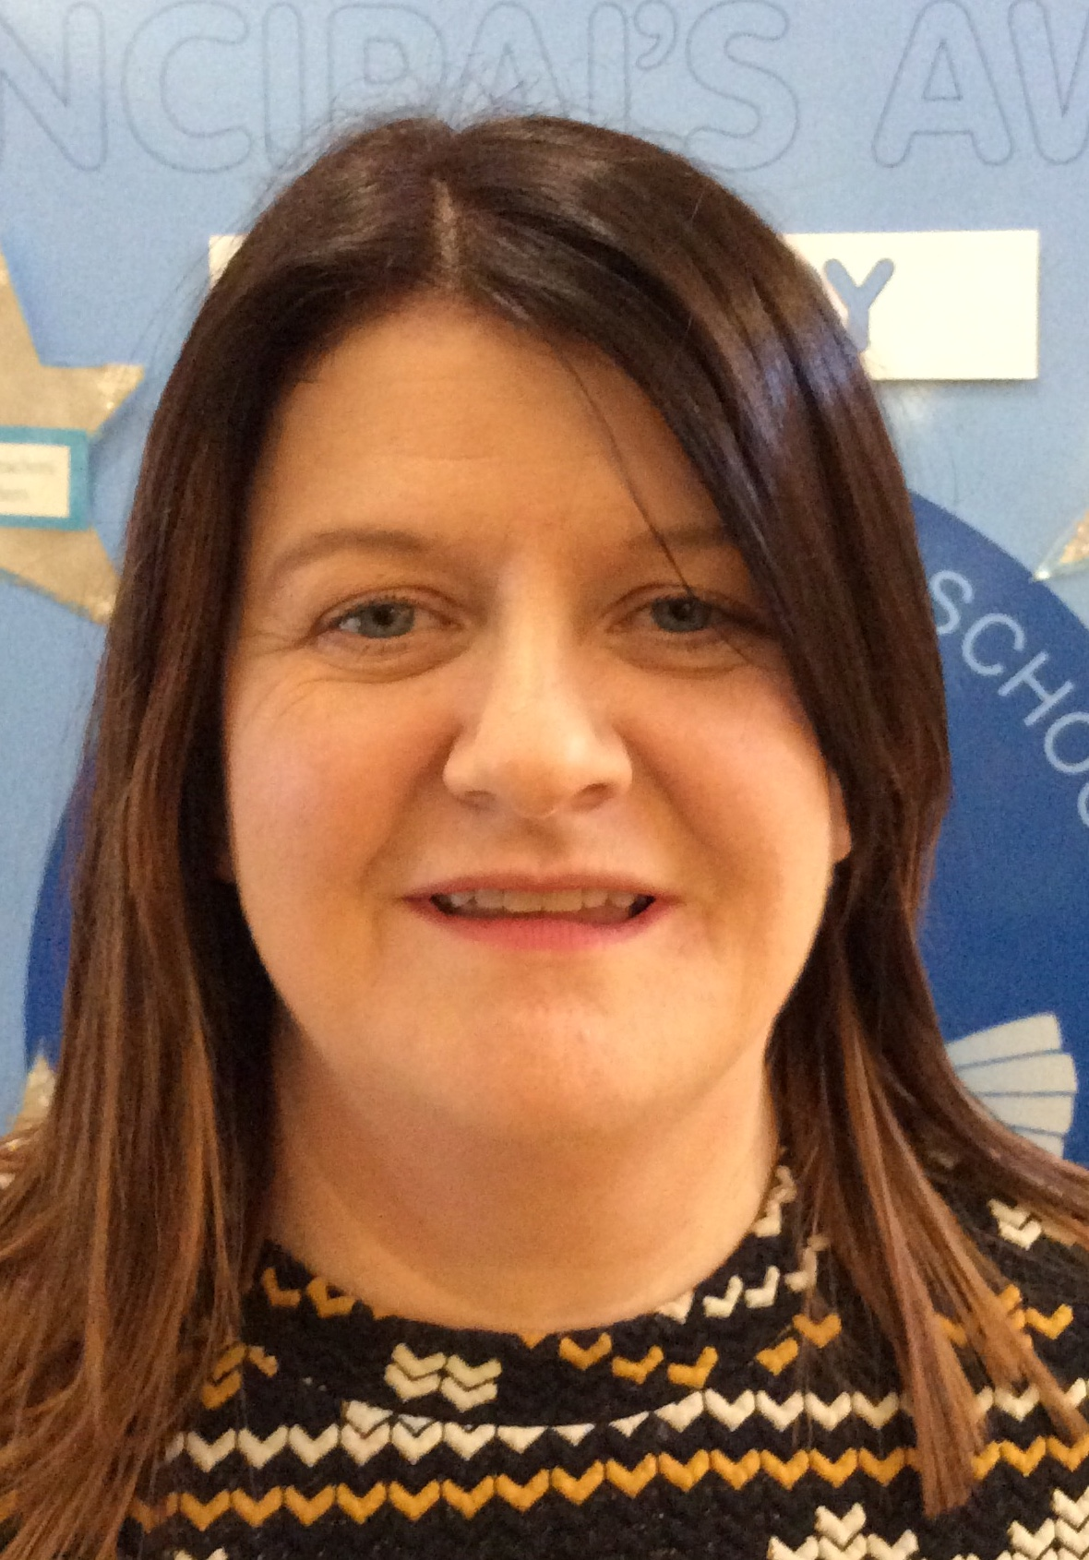

Mrs Tracey Mrs Mc Elroy Mrs Marian Bradley Mrs Carmel Mc Cloy

Designated Teacher Deputy Designated Teacher Chairperson (BOG) Vice Chairperson (BOG)

Designated Governor Designated Governor